Lab 7: Toy Processor with Memory on the Basys2 Board

CSEE 4280 – ADVANCED LOGIC DESIGN
SPRING 2018

Prelab Due (15 pts): March 2 Friday 1:30 PM

Demo Due (40 pts): March 23 Friday 4:30 PM

Report Due (45 pts): March 29 Thursday 5 PM

Total Points: 100

In the last lab, you will be using the Basys2 board. Hopefully you have tested your toy processor with the memory unit with ISim several times. Now we are going to synthesize our design and upload it onto the Basys2 board. We will also write 2 programs in machine code and execute them on the Basys2 board—with your processor.

This lab is divided into 2 parts. In the first part, you will finish the last bit of circuit design to adapt your toy processor to the Basys2 board. In the second part, you will write and load the program onto the Basys2 board.

In this lab, it is important to make sure your project before this point is correct. And it actually saves you time if you test each component before you go on to the next step.

Part 1 Clock and bypass circuits

The clock we will use for our toy processor will be provided by the FPGA. Because this clock is very fast, a program would run in a couple of milliseconds, and we would not be able to see anything but the final result. To get by this, we can use a push-button to generate a clock edge to allow us to manually step through the simulation. Xilinx will not allow the clock itself to be connected to a push-button (we did this in CSEE4270 and ran into a bounce problem), so we will create a finite state machine (FSM) for this purpose. This also accounts for the fact that one push of the button will probably be longer than the normal 100ns clock time, so it is only the initial downward push of the button that is accounted for.

- (Prelab-5 pts) Design a circuit on paper that achieves this goal.
- Create a schematic “clk_signal_sch.sch”.
- (Demo-5 pts) Design a module that gives you the following waveforms. You have two inputs – PUSH and CLK, one output - SGNAL

Symbol clk_signal_sch

- Simulate the schematic. Your results will look like.
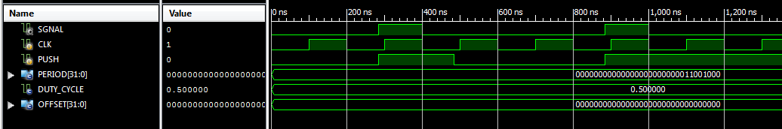

- Generate a symbol for clk_signal_sch.sch

Initially when we are in state zero of the toy processor, it takes 256 clock cycles to transition to the next state. Certainly you don’t want to push a button for 256 times just to get out of state zero. We would like the clock to be automatic when the memory is bootstrapping and to be the manual push-button after that.

1. (Prelab-5 pts) Design a circuit on paper that achieves this goal.
2. Create a schematic “BypassClk.sch”.
3. Design a module that achieves the goal.
4. (Demo-5 pts) Simulate the schematic. Your results will look like:
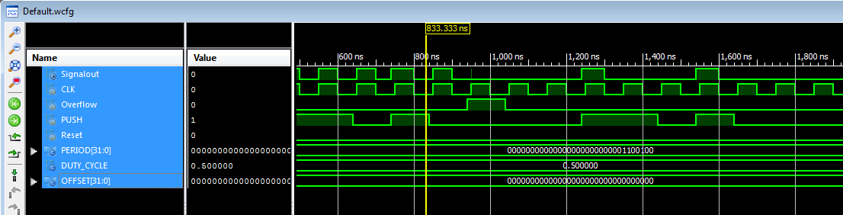

4. Generate a symbol for BypassClk.sch

Part 2 Programming the Basys2 Board

Before you move on, you need include bin_to_7seghex_sch and seven_seg_control_sch from the 4-bit ALU from Lab 2. If they are already in your project, there is no need to re-include them (it wouldn’t make a difference either way). Also, you will need to replace your ROM array with the one in the Lab6 zip file. This is the same as the ROM array that is already in your project, but each ROM 32x1 instance has been labeled manually (a lengthy manual process of which we are sparing you. Please check your ROM array to see if they are properly named.)

Now you are ready to make the final schematic of your ToyProcessor. Open the schematics from the previous lab and change it as follows:
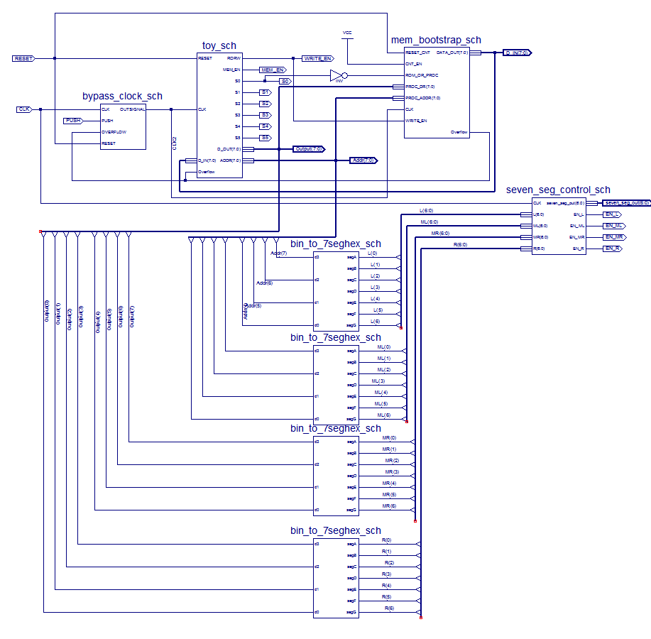
Reset
CLK
D_IN(7:0)
Addr(7:0)
Output(7:0)
seven_seg_out(6:0)
EN_L
EN_ML
EN_MR
EN_R
PUSH
Programming the first Serial Addition Program

Understanding how a program is run on the board is an important part of the final processor. We will illustrate the process using a program that adds up the digits {0,…,9}.


Writing the program entails simply laying out the desired instructions and their accompanying operands/addresses and then converting everything into binary. Remember the convention that the operand/address always follows directly after the instruction in memory. Also, a good programming practice is to start off with a clear instruction at memory location zero. For the summation program, there is the clear and then nine add instructions, each followed by one of the digits {1,…,9}. Finally, the program ends by storing the resulting sum in memory location 100. As you can see below, each line is then written in binary, for the convenience of later initializing it into the ROM array.
BINARY CODE
0. 00000100
00000001
00000001
00000001
00000010
00000001
00000011
00000001
00000100
00000001
00000101
00000001
00000110
00000001
00000111
00000001
00001000
00000001
00001001
00010000
01100100
…
100. 45 (STORED)

0. CLR (ACC=0)
- ADD
- 1 (ACC=1)
- ADD
- 2 (ACC=3)
- ADD
- 3 (ACC=6)
- ADD
- 4 (ACC=10)
- ADD
- 5 (ACC=15)
- ADD
- 6 (ACC=21)
- ADD
- 7 (ACC=28)
- ADD
- 8 (ACC=36)
- ADD
- 9 (ACC=45)
- STORE
- 100 (MEM[100]=45)
…
100. 45 (STORED)
Writing the Program
Leave line 21-99&101-255 blank in the excel script file

Luckily, we have an Excel script to help us initializing the ROM array. The script lets you insert a program in binary and it will tell you the appropriate 8-hexadecimal-digit code to use when initializing each of the 64 ROM components. However, it is also important to understand what is going on behind the script. Each 32 word x 1 bit ROM module is initialized by taking the reverse transpose of the 32x1 bit matrix and converting it into hexadecimal. The result is plugged into the appropriate ROM component as shown in the diagram. For implementation to the board, a User Constraint File (UCF) must be created that contains init statements, such as:
INST "BOOTSTRAP/ROMARRAY/ROM11" INIT = 00000000;

Reverse
Transpose
0…001101110111011101110
0006EEEE
Row 1
8x8 ROM Array
w/ 32 word x 1bit ROM modules
0. 00000100
00000001
00000001
00000001
00000010
00000001
00000011
00000001
00000100
00000001
00000101
00000001
00000110
00000001
00000111
00000001
00001000
00000001
00001001
00010000
01100100
…00000000
31.00000000
Programming the ROM

To use the Excel script to initialize the ROM, open the Excel file named ROM_Initialization_Script. In the second column to the left, enter your code instruction one line for each row. If this is your first time using Excel (for Excel with version earlier than 2003), you may need to install the analysis tool pack of Excel. To do that, select Tools → Add-Ins → Analysis ToolPak in Excel, and click OK. After you are done you excel should look like as follows.
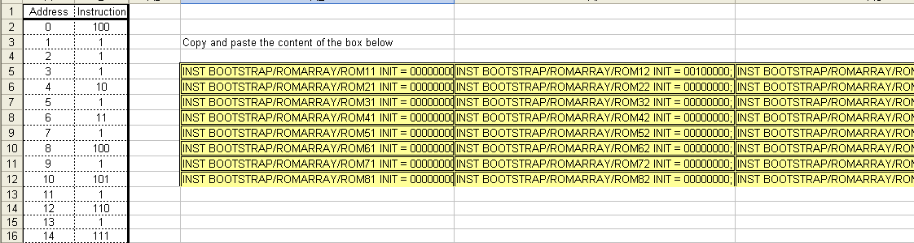

Copy the whole highlighted section to the right. Then you can paste that whole section at the end of the UCF file of the overall project as shown in the attached Appendix. Or you can just input the INIT value by hand in the schematic with values corresponding to each ROM block generated by the excel script.

The name BOOTSTRAP/ROMARRAY/ROMxx is essentially the path from the top level schematics to each 32x1 ROM. This means you should rename your mem_bootstrap_sch and the ROM array inside it to match, like this:

- Open your final toyprocessor schematics, then double-click on the mem_bootstrap_sch block.
- Under InstName, change the value to BOOTSTRAP then press OK.
- Now open you mem_bootstrap_sch schematics and double-click on the ROM_array block.
- Under InstName, change the value to ROMARRAY and press OK.

When generating the UCF you should think about which LEDs, switches and buttons you would like to use for your inputs and outputs. Choose wisely, as it can make debugging and operating your toy processor much easier. Make sure you show all the important outputs on LEDs (such as the value of the accumulator), and that you connect all the important inputs to buttons/switches (such as the manual clock). Make sure your toy processor schematic is set as top module and that there are no other UCF files in your project. Now add your new UCF, then load the on Basys2 board as before. Your Basys2 board is programmed. You need to test it by yourself.
(Demo-15 pts) Demo and explain how this program is working on your board.

Programming the second Serial Addition Program

Once you get the first serial addition program of 0 to 9 working, you will need to design a second and different program to achieve the same goal - adds up the digits {0,…,9}. The requirement of this second program includes:
- It needs to be self-modifying program
- It needs to use index
- It needs to use all 5 instructions
(Prelab-5 pts) As part of prelab, you need to show the ideas of designing such a program. (Demo-15 pts) Demo and explain how this program is working on your board.
Appendix

Here is an example UCF file for the first program. Yours may look different if you used other names for the signals and for the ROMS.

###Auto generated UCF file for BASYS2 Board

NET S0 LOC=M5; # Discrete LED 0 (active high)
NET S1 LOC=M11; # Discrete LED 1 (active high)
NET S2 LOC=P7; # Discrete LED 2 (active high)
NET S3 LOC=P6; # Discrete LED 3 (active high)
NET S4 LOC=N5; # Discrete LED 4 (active high)
NET S5 LOC=N4; # Discrete LED 5 (active high)
NET MEM_EN LOC=P4; # Discrete LED 6 (active high)
NET Overflow LOC=G1; # Discrete LED 7 (active high)

### BASYS2 7-Segment LED:
### BASYS2 digit enables:
NET EN_L LOC=K14; # left digit enable (active low)
NET EN_ML LOC=M13; # middle left digit enable (active low)
NET EN_MR LOC=J12; # middle right digit enable (active low)
NET EN_R LOC=F12; # right digit enable (active low)

### BASYS2 segment enables:
NET seven_seg_out<0> LOC=L14; # LED display segment a (active low)
NET seven_seg_out<1> LOC=H12; # LED display segment b (active low)
NET seven_seg_out<2> LOC=N14; # LED display segment c (active low)
NET seven_seg_out<3> LOC=N11; # LED display segment d (active low)
NET seven_seg_out<4> LOC=P12; # LED display segment e (active low)
NET seven_seg_out<5> LOC=L13; # LED display segment f (active low)
NET seven_seg_out<6> LOC=M12; # LED display segment g (active low)

NET Reset LOC=M4; # Pushbutton 2 (active high)
NET PUSH LOC=A7; # Pushbutton 3 (active high)

NET CLK LOC=B8; # clock

INST BOOTSTRAP/ROMARRAY/ROM11 INIT = 00000000;
INST BOOTSTRAP/ROMARRAY/ROM12 INIT = 00100000;
INST BOOTSTRAP/ROMARRAY/ROM13 INIT = 00100000; …….

Appendix

Schematics of final processor and implementation

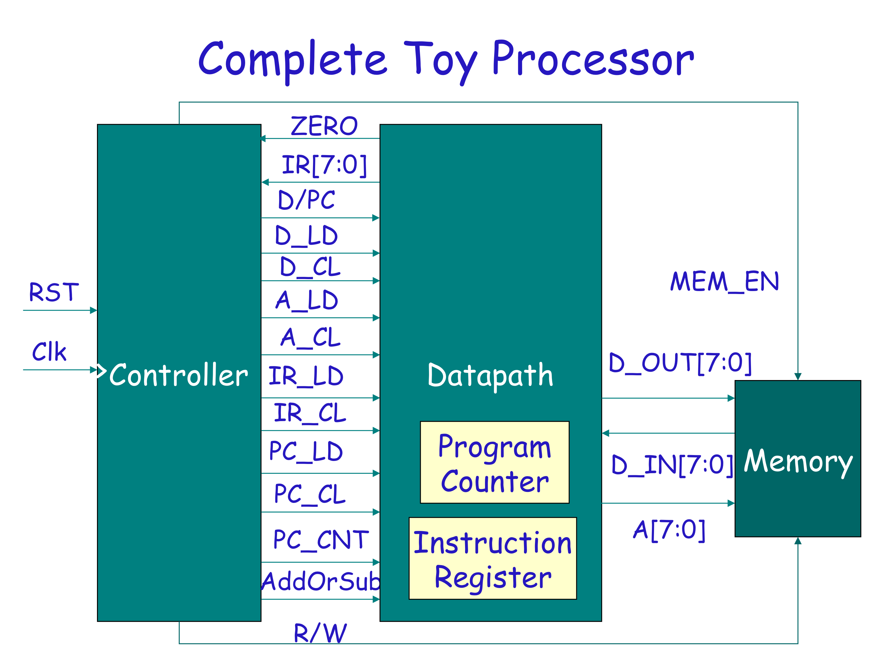

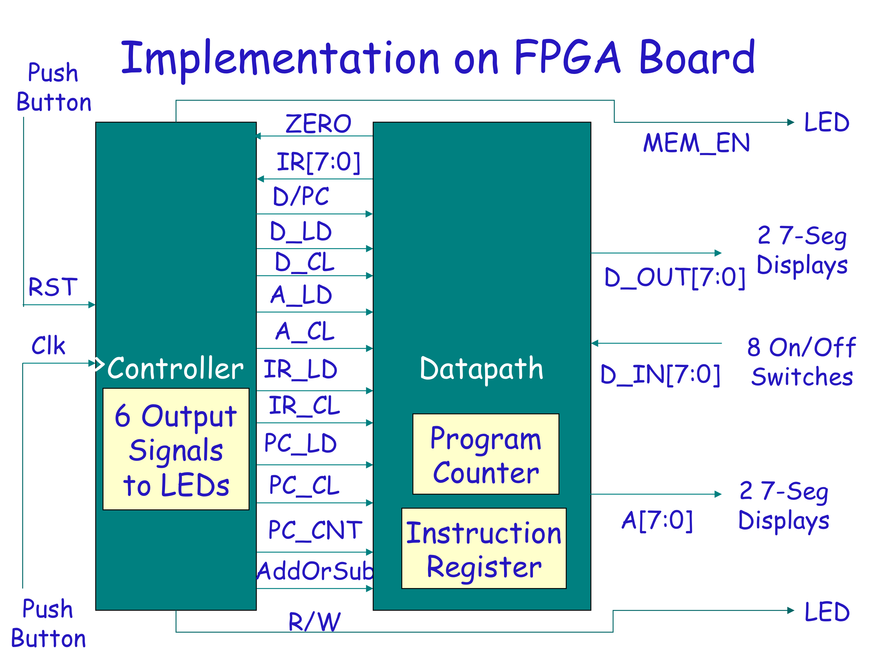

Lab Report/Code Requirements

Lab Report Format

Each team should submit one report using the format provided below. You should provide a detailed description/discussion for each lab report item including all schematics, codes and simulation waveforms from testbench. The lab report should be in WORD or PDF format and submitted as a single file to the dropbox in ELC. Please submit your lab reports in appropriate assignment folders on ELC before the deadline. 30% credit will be taken off if the submission is late by 0-24 hours. After 24 hours, late submission will not be accepted and zero credit will be given to the lab report.

1. Student Information (First page)

Lab Number and Title:
Names of members in the team:
E-mails:
Contributions: Please list contributions (in estimated percentages) of each member in the following categories.
- Pre-lab design and analysis
- In-lab module and testbench design
- In-lab testbench simulation and analysis
- In-lab FPGA synthesis and analysis
- Lab report writing

2. Lab Purpose (Second page)
Provide a brief summary of the lab assignment.

3. Implementation Details
Provide a detailed description of the steps you followed to implement the lab. Be sure to include all relevant information. Recommended information to be included:
- Pre-lab design and analysis
- Schematics of your design if available
- Module and testbench code

4. Experimental Results
Describe the results of the lab assignment. Be sure to include any simulation waveforms for testbench. You need to summarize the simulation results, supplemented by the evidence from Screen Captures of the waveforms. Please DO NOT just copy the waveforms as the results. You need explain why they correctly verify your design. When you attach the waveform screen captures, please crop them so that the variables names, time scale and waveforms are visible in your file.

5. Significance
What is the importance of the lab? How will you use the information you learned in this lab in the future?
In which applications you can use this information?

6. Comments/Suggestions
Please provide any comments or suggestions you may have for this lab assignment. Please indicate any areas of difficulty you encountered for this lab assignment.

7. Additional Lab Specific Information
Attach any additional information requested for this lab, including schematics, simulation waveforms, or manually performed tasks.
Grading Policy
Only one copy of the lab report from each team is needed. The grade for the report will apply to both team members, provided that each team member contributes roughly equally (50/50 – 40/60) to the lab. In the case where one team member contributes disproportionally lower to the lab, the instructor may reduce the grade of this member. Late submission after due date will receive partial credits (70% of credit for 0-24 hours late submission, no credit for more than 24 hours late submission).
Plagiarism: If plagiarism is found in reports, all of them will get ZERO points immediately, and face serious consequences.

